**App Overview:**

Wealth AI is an investment guidance application designed to assist users in making informed decisions in the stock and cryptocurrency markets. The app leverages prediction models to provide personalized investment suggestions based on the user's risk tolerance. Key subsystems include user authentication, market data analysis, investment suggestion engine, and portfolio management. Please note that the scope and details of the application might change as I move forward. For example, I might slightly change the UI or change the parts of the prediction model or slightly add or remove features given the big scope of this proposal.

**Major Challenges**

Integrating real-time stock and cryptocurrency market data.

Implementing a secure and efficient user registration and login system.

Ensuring the app's user interface is intuitive and user-friendly, especially the presentation of complex data.

Developing reliable prediction models for investment suggestions.

Store user data accurately.

**User Interface Sketch**

User interface will include a user registration page. After the user is registered, three options will be suggested. Option 1 is going to be the investment suggestions given the current state of the market. Option 2 is going to be to be for the selected stocks information and predictions. Option 3 is going to be the page where user can see the previous investments he made (the user can view his portfolio). Figures 1-4 show the application sketch.

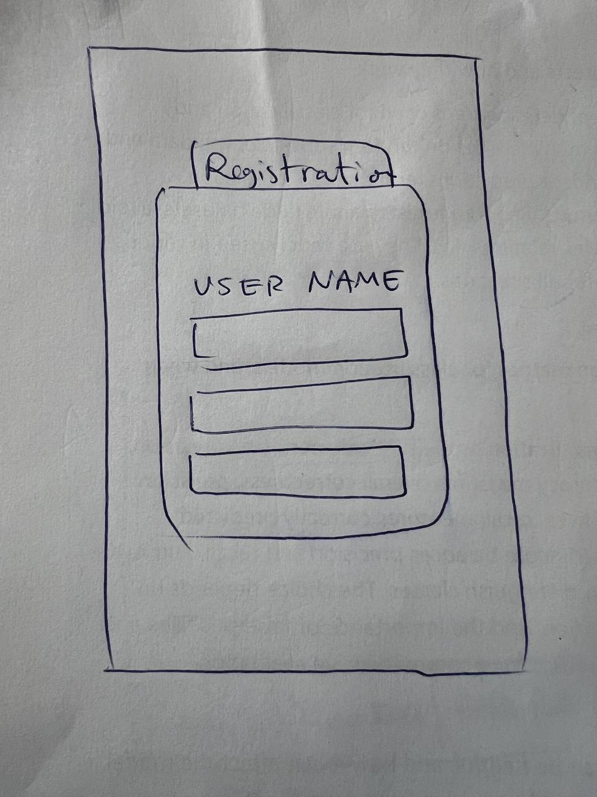

Figure 1. Login/Registration screen.

Figure 2. Dashboard displaying market trends and investment suggestions.

Figure 3. Detailed view of stock/crypto predictions for the next 10 days.

Figure 4. User portfolio overview, highlighting suggested positions.

**Schedule (Week-by-Week)**

1. Integration of user registration and login with Firebase.
2. Market data API selection and integration.
3. Initial UI design and development.
4. Implementation of the portfolio management feature.
5. Final touches and preparation for the demo.

**Potential APIs**

Firebase Authentication for user registration and login.

Financial market data API (e.g., Alpha Vantage, CoinGecko) for stock and crypto data.

Chart.js for data visualization.

The APIs could change given the limitations that each one might have. I need more time for investigation to select the appropriate API for visualization and data.

**Functional Specification for Demo**

For the demo, I will present:

The user registration and login process.

Real-time fetching and display of stock/crypto market data.

An example of investment suggestion based on predefined risk tolerance.

Visualization of predictions for the next 10 days on a chart.

A mockup of the user portfolio based on suggested positions.

**Comparative Analysis**

Similar apps include Robinhood and Coinbase, which offer investment suggestions and portfolio management. Wealth AI differentiates itself by focusing on personalized investment guidance through predictions tailored to the user's risk profile.

**Technical and Usability Aspects**

Technical Breadth: Utilizes Firebase for authentication, third-party APIs for market data, and machine learning for investment predictions.

Usability: Emphasizes an intuitive UI, easy navigation through complex data, and functionalities like reinitialization without quitting.